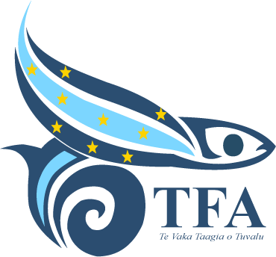
Tuvalu Fisheries Authority
Press Release
Tuvalu Fisheries Authority Secures NZ$10.9 Million Grant for Third Phase of Fisheries Support Programme
Funafuti, Tuvalu – Friday, 1 May – The Tuvalu Fisheries Authority (TFA) has signed a Grant Funding Contract with New Zealand’s Ministry of Foreign Affairs and Trade (MFAT) for the third phase of the Tuvalu Fisheries Support Programme (TFSP3). The agreement was signed by the Managing Director of TFA on Friday, 1 May.
TFSP3 will provide funding to support the implementation of TFA’s Corporate Plan, with the aim of increasing economic and food security benefits for Tuvalu through the sustainable management of its fisheries resources. The contract provides a total budget of NZ$10.9 million over a five-year period. In addition, two long-term technical advisers will be recruited and provided separately by MFAT to support the programme’s implementation.
The third phase of the programme will build on more than ten years of New Zealand assistance to Tuvalu’s fisheries sector. TFSP3 will continue successful activities that have contributed to maintaining revenue from oceanic fisheries, while also supporting local fishing and fish marketing initiatives. A new emphasis will be placed on strengthening TFA’s institutional capacity, particularly in financial management, human resource management, and governance support for the Board of Directors.
The programme will also focus strongly on maintaining and enhancing fisheries assets. One of the first contracts to be signed under TFSP3 will support a programme of repairs and maintenance for the fisheries vessel Manaui II, restoring its operational readiness.
Commenting on the agreement, TFA Managing Director Sam Finikaso acknowledged New Zealand’s ongoing support for Tuvalu’s fisheries sector.
“New Zealand has been a great supporter of fisheries in Tuvalu,” said Sam Finikaso. “They provide practical and flexible assistance to help us achieve our own objectives. This third phase of the programme will provide more resources than either of the two earlier projects, and we expect excellent results.”
ENDS
For further information please contact TFA’s Media and Communications Officer Penivao Lonesi at penivaol@tuvalufisheries.tv

